ELEC ENG 3TP3 – Lab 3
Aliasing in Signal Sampling

Amaiam Ul Haque – haquea24 – 400520641
Dr. Thia Kirubajan
December 2nd, 2025

Notes
- All descriptions necessary are comments within the code.

- Save the current figure using:
exportgraphics(gcf, 'filename_you_want.jpg');
This method will strip off excess whitespace around the figure.

- Place text on each graph:
text(100, 1, 'Amaiam Ul Haque, 400520641', 'FontSize', 11);
Will place Amaiam Ul Haque at coordinate location (100, 1) on the current plot.

- Must include Matlab and how it works in the comments.

- %% = bolded and sectioned comment (like a header)

- To plot multiple signals:
X = linspace(0,2*pi,50)';
Y = [cos(X), 0.5*sin(X)];
stem(Y)
Or:
stem(signal1); hold on;
stem(singal2);
From MATLAB Help Center – Stem page (right click on any stem usage in Matlab editor and select Help on “stem” option).

- Signal convolution:
y = conv(A, B)
Returns vector y, and is convolution of vector A and vector B, and has length of length(A) + length(B) - 1.

- Smooth line / continuous plotting: plot()
- Data points / discrete plotting: stem()

Aliasing in Sinusoidal Signals

Question 1
Plotting x(nT) using the commands stem() and plot() result in the two figures below respectively. stem() results in a plot with various discrete data points, while plot() results in a plot with a smooth continuous data line, even though both graphs use the same signal to be plotted.

Figure(s):
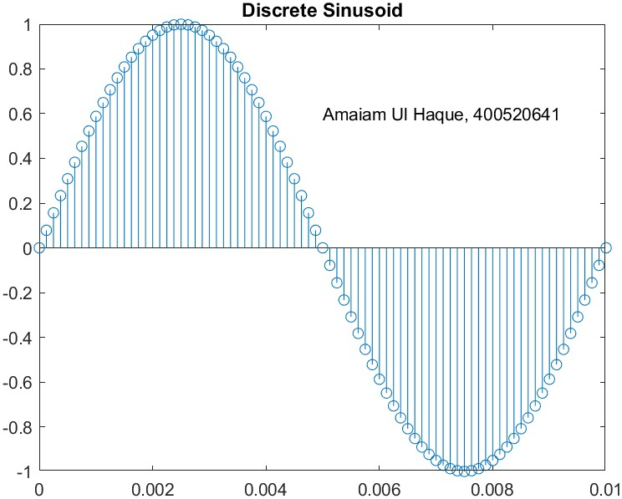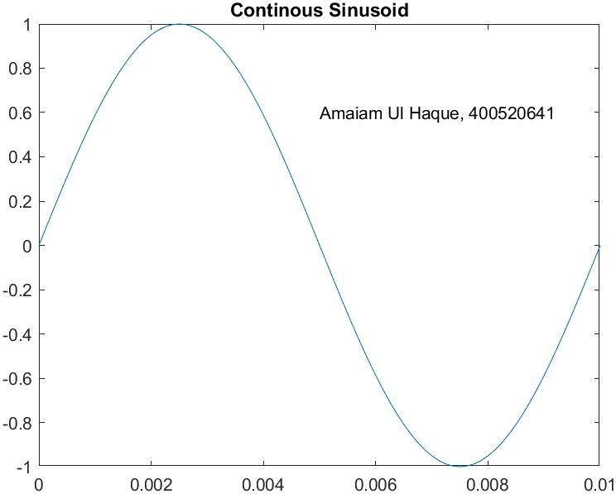

Code:
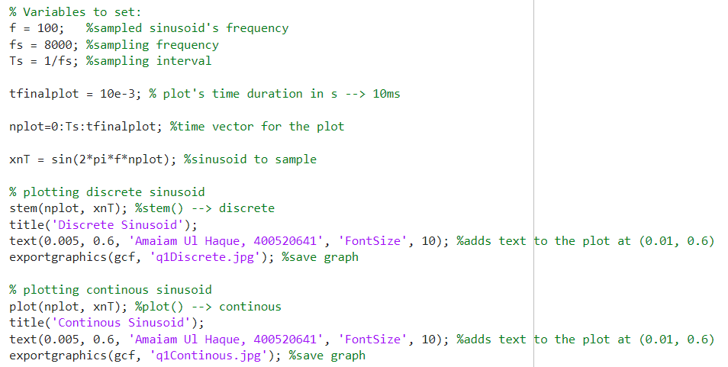

Question 2
Upon hearing the 8 second audio file, 4 distinct tones/sounds are heard, each for 2 seconds long and increasing in pitch, with the 100Hz being the lowest pitch, and 800Hz being the highest pitch.

Figure(s):
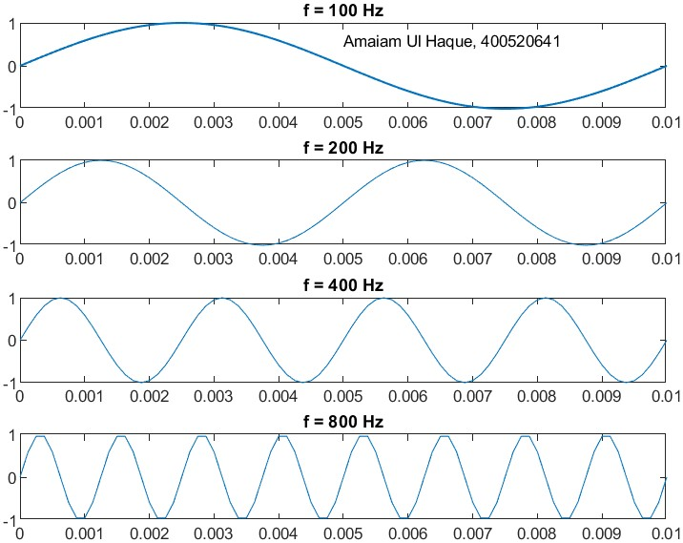

Code:
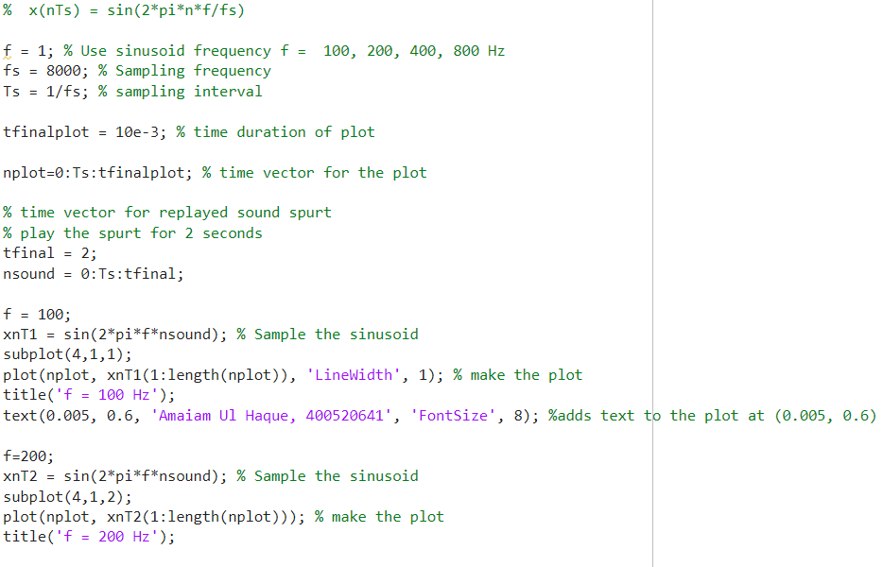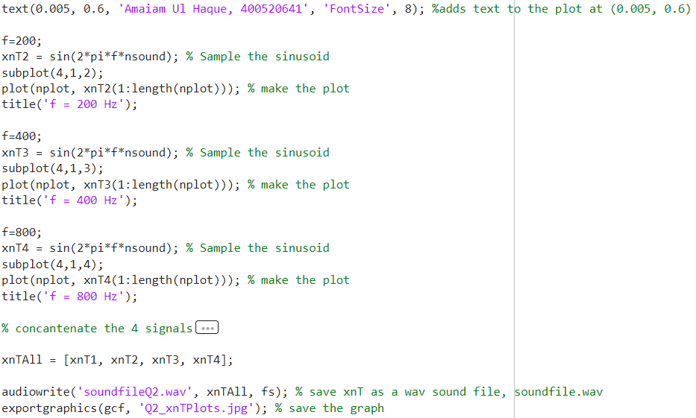

Question 3
Upon hearing the 8 second audio file, 4 distinct tones/sounds are heard, each for 2 seconds long and decreasing in pitch, with the 7200Hz being the highest pitch, and 7900Hz being the lowest pitch.
Even though the frequency themselves are increasing (from ascending order of 7200, 7600, 7800, 7900 Hz), the audio heard is decreasing in pitch. This is a result of the frequencies being above the Nyquist limit. The Nyquist limit is half of the sampling frequency as shown below:
$$f_{N}=\frac{f_{s}}{2}=\frac{8000}{2}=4000 Hz$$
These frequencies are above $f_{s}$, causing aliasing. The aliased frequency is given by:
$$f_{a}=∣f-kf_{s}∣$$
where $k$ is an integer such that $f_{a}≤f_{N}$.
- $f=7200\text{ Hz}$: $f_{a}=∣7200-8000∣=800\text{ Hz}$
- $f=7600\text{ Hz}$: $f_{a}=∣7600-8000∣=400\text{ Hz}$
- $f=7800\text{ Hz}$: $f_{a}=∣7800-8000∣=200\text{ Hz}$
- $f=7900\text{ Hz}$: $f_{a}=∣7900-8000∣=100\text{ Hz}$
Hence, the audio produces 4 tones of decreasing pitches in the descending order of 800, 400, 200, 100 Hz frequencies.

Figure(s):
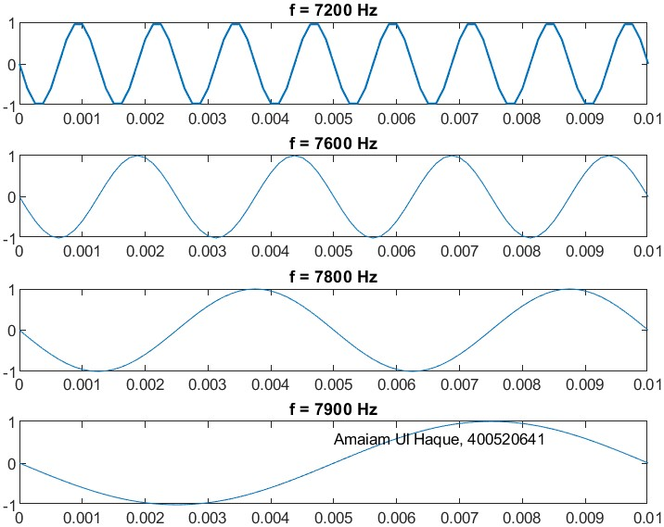

Code:
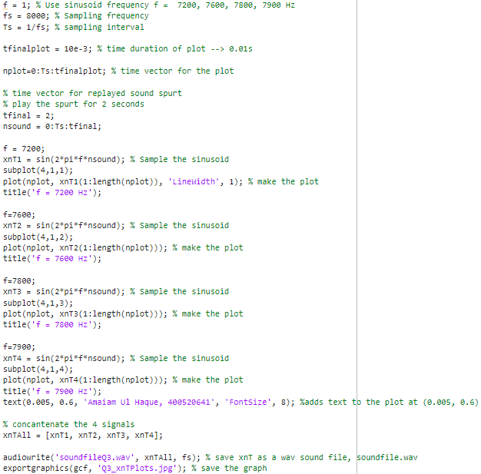

Question 4
Without anti-aliasing pre-filtering, the performance of the telephone system would degrade significantly because of aliasing distortion.
When input signals contain frequency components above the Nyquist frequency ($f_{N}=4\text{ kHz}$ for $f_{s}=8\text{ kHz}$), these components are not captured correctly by the sampling process. Instead, they "fold back" into the audible frequency range (0–4 kHz), appearing as lower-frequency interference. This results in:
- Distorted voice signals
- Introduction of false tones not present in the original speech
- Reduced intelligibility and naturalness of conversation

How Anti-Aliasing Filtering Prevents Negative Effects:
An anti-aliasing filter is a low-pass filter placed before the analog-to-digital converter (ADC) in the telephone exchange. Its purpose is to attenuate frequency components above $f_{N}$ before sampling.
- Cutoff Frequency: Typically set just below 4 kHz (e.g., 3.4–3.5 kHz) to account for filter roll-off.
- Filter Type: Usually a sharp analog filter (e.g., Butterworth or Chebyshev) to strongly suppress frequencies above 4 kHz.
- Effect: Any signal content above ~3.5 kHz is greatly reduced in amplitude, so that by the time sampling occurs, the remaining energy above $f_{N}$ is negligible and will not cause significant aliasing.

What Would Happen in the Experiments if Filtering Were in Place:
- Low-Frequency Sinusoids (100–800 Hz):
No change, since they are within the passband.
- High-Frequency Sinusoids (7200–7900 Hz):
These would be heavily attenuated by the filter. The sampled signal would contain almost no energy, and the reconstructed output would be silence or very faint noise—not the aliased tones heard in the experiment.

Aliasing of a Frequency Chirp Signal

Question 5
Describe and explain what you see and hear in both cases.
As shown in the figure below, the chirp signal plotted is a sinusoidal function that gets compressed/its period is reduced more and more as time goes on. The resulting audio also mirrors the same results, as the audio’s pitch linearly increases as more and more time passes.

Figure(s):
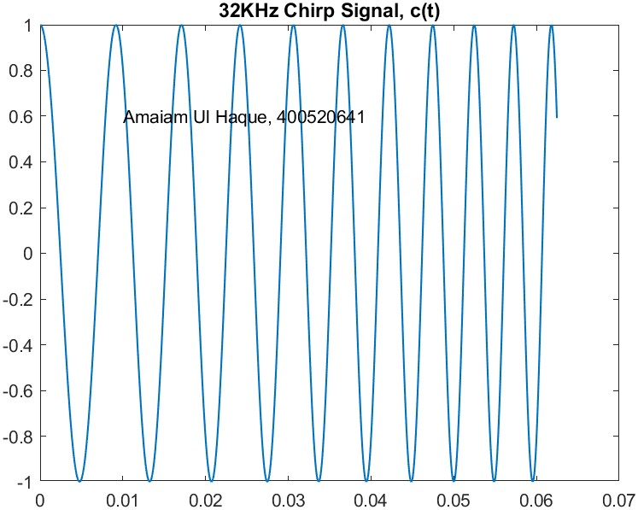

Code:
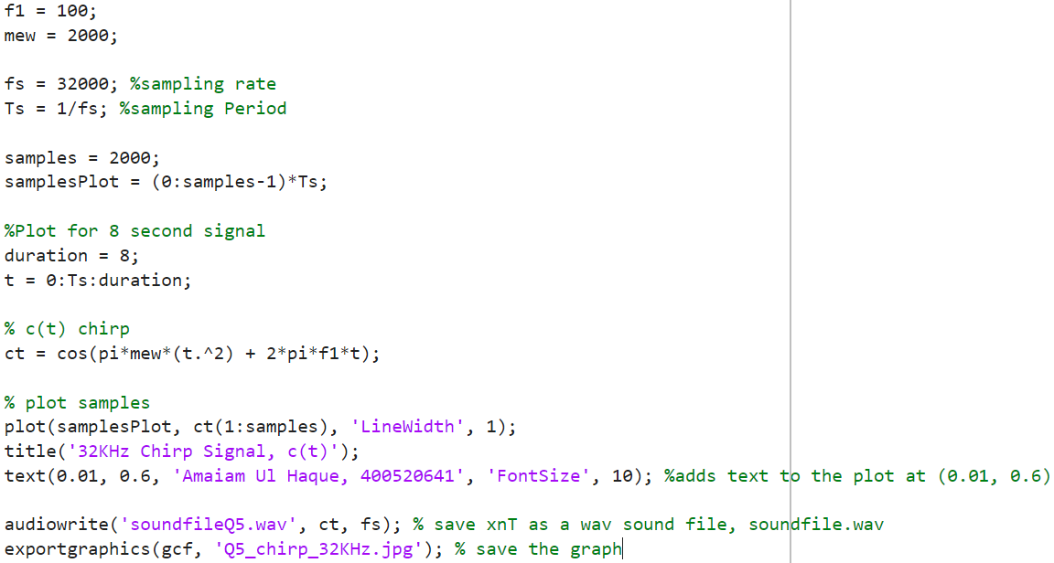

Question 6
The same experiment was repeated with reduced sampling frequencies to observe aliasing effects. First, $f_{s}$ was lowered to 16 kHz, and then to 8 kHz — the latter simulating transmission through a digital telephone network without anti-aliasing filtering.
At $f_{s}=16 \text{kHz}$, the initial portion of the audio resembled the 32 kHz case, but the pitch increased only until the Nyquist limit (8 kHz) was reached. Beyond that point, aliasing caused the perceived frequency to decrease, creating a descending pitch effect for the remainder of the clip.
At $f_{s}=8 \text{kHz}$, this fold-back behavior occurred twice as rapidly, resulting in repeated cycles of rising and falling pitch throughout the audio.
If anti-aliasing filtering were applied (as in actual telephony), frequencies above approximately 3.5 kHz would be attenuated before sampling. The chirp would thus rise only to the filter’s cutoff frequency and then remain bounded, eliminating the aliasing-induced pitch reversals heard in the unfiltered experiments.
Additional tests were conducted by varying $f_{1}$, $f_{s}$, and $μ$.
- Increasing $f_{1}$ raises the starting pitch; if $f_{1}$ exceeds the Nyquist frequency, aliasing immediately shifts the perceived tone to a lower frequency.
- Lowering $f_{s}$ increases aliasing, causing more frequent pitch folding and distortion.
- Increasing $μ$ accelerates the chirp’s frequency sweep, leading to more rapid aliasing cycles, while decreasing $μ$ slows the perceived pitch variation.
These observations confirm that aliasing arises when the signal’s instantaneous frequency exceeds $f_{s}/2$, and that proper anti-aliasing filtering is essential to preserve signal integrity in sampled systems.

Figure(s):
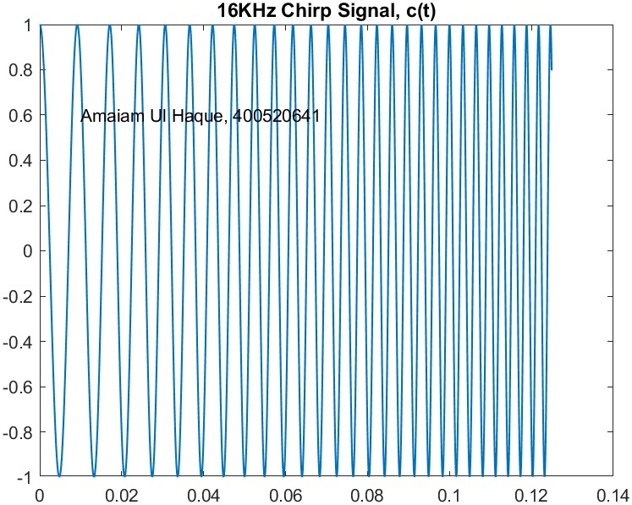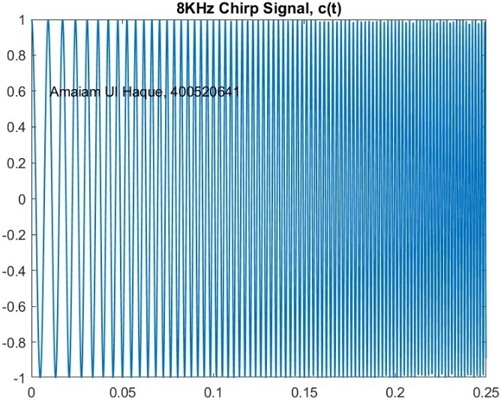

Code:
